Solution Architecture Design Document (SAD)
Project Title:
Enterprise Multi-Account Event-Driven Customer 360 & Engagement Platform on AWS
Version: v1.0
Author: Solution Architect

1. Executive Summary
This document defines the solution architecture for an enterprise-grade, multi-account, event-driven Customer 360 platform on AWS. The solution unifies fragmented customer data across multiple channels and enables real-time engagement while meeting security, scalability, and operational excellence requirements.

2. Business Context and Problem Statement
Enterprises interact with customers through multiple digital and enterprise channels (web, mobile, CRM, support systems). Customer data is fragmented, delayed, and siloed, preventing real-time engagement and unified insights.
Key Drivers
- Unified customer view (Customer 360)
- Real-time engagement
- Enterprise security and isolation
- Global scalability
- Analytics without operational impact

3. Solution Objectives
- Capture customer events in real time
- Unify fragmented customer data
- Enable event-driven engagement
- Enforce enterprise multi-account governance
- Provide analytics and insights

4. High-Level Architecture Overview
Account Structure
- Management Account – AWS Organizations, billing
- Security Account – Security Hub, GuardDuty, logging
- Production Account – APIs, EventBridge, Lambda
- Data Account – S3 data lake, Glue, Athena
- Operations Account – Monitoring and observability

5. End-to-End Architecture Flow
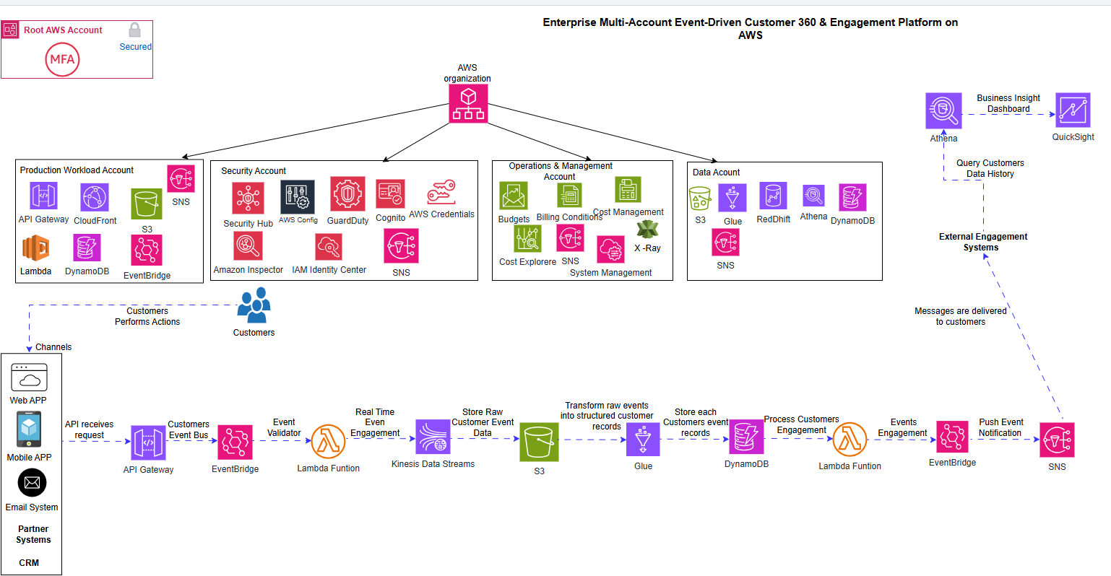

6. Explanation of “Across Channels”
Channels are event producers, not data stores.
Examples:
- Web applications
- Mobile apps
- CRM systems
- Support platforms
- Marketing platforms
All channel data is centralized in AWS, not stored in the channels themselves.

7. Governance and Security
- Multi-account isolation
- Least-privilege IAM
- Centralized logging
- Encryption at rest and in transit
- Event schema governance

8. Cost Model (Design-Time)
- Serverless and managed services
- Pay-per-use event processing
- S3-based analytics instead of duplicated warehouses
- Cost allocation via account boundaries and tagging

9. Risks and Trade-Offs
Risk | Mitigation
Event duplication | Idempotent consumers
Cost growth | Budgets and alarms
Schema drift | Event versioning

10. Conclusion
This architecture delivers a secure, scalable, and event-driven Customer 360 platform aligned with AWS enterprise best practices. It enables real-time engagement, analytics, and long-term extensibility while maintaining strong governance.

